**The University of the Witwatersrand**

**ELEN 1002 – Concepts of Design**

**BSc Applied Computing**

**Project 1:**

**Hoverboard Design**

**2013**

**Name:** Jason Max Chalom

**Student Number:** 711985

**Date of Submission:** Tuesday 2nd April 2013

**Abstract:**

**This report describes a design for a theoretically functional hoverboard. It functions based on a physical property of fluid dynamics where a solid body can glide on a pocket of air which is pushed below the hoverboard by an electrically propelled rotor. There were constraints where the hoverboard must not only hover but also travel horizontally at a speed of 30km/h while carrying an 80kg person. Assumptions were made about the theoretical surface which the hoverboard travels being flat and smooth and that there is an unlimited budget given to the design. Calculations were made to find the weight of the proposed design which is found to be 130kg. The Static Thrust was found to be 1274N of force. The design is able to output 970.125W of power downwards making it accelerate vertically at 0.15m.s-2 and it is able to reach a maximum height of 0.15m. It is able to reach 30km/h horizontally in forty seconds. The hoverboard uses Bluetooth technology so that the user controls the device using their cellular phone. The hoverboard is made of printed sheets of nylon plastic and this makes it quite environmentally friendly. It is also safe to use. Unfortunately a desirable design which is attractive, compact and practical is not truly possible with current technology but in the near future such a design will most definitely be attainable.**

1. **Introduction**

The task given was to design a viable hoverboard which is able to hover and travel horizontally. The design must incorporate currently available and existing technologies. Ideas from a range of fields including electronics, computational devices and aeronautics have to be used to create a solution which is plausible. The idea of the hovercraft comes from the movie, ‘Back to the Future Part II’.

**Aim and Hypothesis**

The aim is to prove that it is viable with current technology to design and build a functional and useable hoverboard which is practical and safe.

Hypothesis: The design which has been created is a viable solution which is practical and has economic viability in being desirable to the prospective customers.

1. **Background**

Since the film, the challenge to design a functional and also viable hoverboard has been the dream of many hobbyists and engineers. The movie’s idea of a hoverboard encompassed one important ideal which is simplicity. The board was simplistic and intuitive for the user. It was of similar design to the skateboard which made it recognisable and intuitive for a first time user to set up and ride.

The ability to create a device which hovers above the ground is plausible and has even been done to some degree of success. (See 2.1) The problem in designing a hoverboard incorporates the ‘wicked problem’ where the technology required to make the device hover and to overcome its weight and gravity itself is very heavy and so does not solve the problem but makes it worse.

Modern Technology is becoming ever smaller as well as more capable. New electric motors with the torque and power outputs to rival more conventional engines and motors and new battery technology which is lighter, more efficient and able to store more energy has been developed.[1]

* 1. **Current Solutions**

The major attempts to create functional hoverboards have been by hobbyists who have basically used thin plywood or similar material, with a leaf blower attached as propulsion and other variations such as aerodynamic components or varying types of skirts to produce an air pocket for the board to ride upon. [2] These hobby solutions make use of the hover principle in order to function. (See 2.2). These solutions have many problems including safety, being very noisy and also not being very energy efficient.

Another solution which has been created is to use electromagnets as a form of levitation.[3] This system uses less space and weighs less and in that respect this solution would be preferable. This solution requires a specific base which acts as an opposing electromagnetic force. This is a problem because the board will only be effective when it is on top of a specific surface design specifically for the board and so it is limited to a specific area and is not a ubiquitous device. The magnets may also interfere with electrical devices and its surrounding environment. The most problematic part of this specific solution is that it can only hold its own weight and not that of a load due to the strength of the magnetic field used. A stronger magnetic field would require too much power to produce.

* 1. **The Hover Principle**

All hovercrafts that use air as their primary propulsion work on the same principle. These devices create an air pocket below their bases which they then ride. This is a similar idea to surfing a wave in the ocean since this encompasses fluid dynamics. The air pocket uses Newton’s Laws to overcome gravity. The air pocket is created by the device but it acts as an opposing force upon the craft and the ground like a cushion. This force produced by the air pocket on the craft is greater than the weight of the craft and so it will oppose gravity and it will seem to the observer that the craft is floating while it is actually resting on a high pressure pocket of air which is wedged between the ground and the craft.

This principle is the fundamental physics used in many types of hovercrafts, hover based machines and even some types of boats and aircraft.

* 1. **Equipment**

The equipment used in the lab to assess the design will mainly be devices such as GPS location and infrared speed trapping devices to assess the speeds on the prototype in the real world once it is built[5].There are also cameras to document the experiments done with the prototype. A Selective laser sintering(SLS) machine is also used to create the prototype since the use of light, strong and durable plastics which can be moulded straight from CAD data is desirable[6]. Thermometers will be used to measure the heat output produced by the prototype and assess the risk factors involved with the device. Weights will be used to test the prototype without the use of a person in early trials.

* 1. **Constraints and Assumptions**

The constraints provided are that the device must be able to hover above the ground, hold an 80kg person, travel up to a speed of 30km/h and have certain safety considerations.

Assumptions:

It has been assumed the force due to gravity (g) is 9.8m.s-1 and that the centre of gravity is in the middle of the board is balanced. The assumed time for upwards acceleration when the board increases its hover height will be 5 seconds. It is assumed there is no friction or wind resistance acting upon the hoverboard and that the surface which the board flies over is flat and not rugged. The nylon plastic used is assumed to have a thickness of 0.01m or 10mm. There is also an unlimited budget for this project.

1. **Design**

This design has taken into account many considerations such as aerodynamics, upward lift and directional thrust. The design still conforms to the idea of a Hoverboard. (See Appendix A. for the technical drawings.)

This design makes use of similar design components from [2] such as the shape of the skirt under the board. The major difference is that the skirt for the hoverboard is solid yet flexible and not like the one in [2] which is malleable to the shape of the air pocket under their design which itself able to change and conform to the surface underneath. This rounded skirt and middle vent design is very effective and one of the only ways which have been found to create a continuous air-pocket under the hoverboard which is stable and effective.

Many different propulsion systems were considered in choosing an air hovering design. Rocket propulsion was considered but there were many safety concerns such as making the proposed design a fire hazard and also dangerous towards the user. Magnetic levitation was also considered but it would take too much energy to levitate are large load such as one which is over 100kg. Another problem is that for magnetic levitation to work a specific surface would be required to oppose the magnetic force of the hoverboard. This would mean that the hoverboard would only work in a specific and defined location whereas one of the specifications of the project was that the hoverboard is able to travel over any surface. The surface has been assumed to be flat but not necessarily have any special construction.

* 1. **Material**

SLS is able to create products from many different types of materials such as plastics and metals. SLS can also be done with recycled materials. Nylon is very light, durable and has a specific gravity of 1.00 g/cm3.[7] This is the construction material chosen to be used in building the hoverboard.

* 1. **Parts**

The design incorporates an Arduino DUE microcontroller, which has an operating voltage of 3.3V and an input voltage of 6-20V. It has a processing speed of 84Mhz which is enough to run the hoverboard.[8] This microcontroller is opensource which makes it simpler to program and implement than proprietary microcontrollers and it does not come with any licensing problems.

There is a standard battery pack which holds 4x AA batteries which powers the microcontroller.

An Arduino Bluetooth Shield is used to allow the microcontroller to communicate with the user’s cellular phone. It is a standard serial port module.[8]

The hoverboard makes use of a couple of Arduino relay shields for the microcontroller to control the electric motor and magnetically opened vents on the hoverboard. These are standard relay switches.[8]

There is a MinIMU-9 v2 Gyro, Accelerometer and Compass unit used in the hoverboard as a sensor for the microcontroller to monitor the hoverboard. It has a 3-axis gyro and an accelerometer which are used to detect the orientation of the hoverboard so that the microcontroller can compensate for changes in its orientation.[8]

The main two components of the hoverboard is the two batteries and the electric motor which actually are designed for electric dirt bikes. The batteries are each 48V 20AH LiFePO4 Battery Packs. They each weigh 9.9kg and have dimensions of 195x210x150 mm which fit into the two portions of the skirt under the hoverboard. The batteries are rated to work with a 1200W electric motor. They also come with a 2A charger[9] The Motor is rated as being 48V with a power output of 1200W and weighing 3 kilograms.[10]

The electromagnets used to open and close the vents in the hoverboard are simple tubular electromagnets. They have 10mm diameters and are 17mm long.[11]

The propeller is also printed nylon plastic with a SLS machine.

* 1. **Control**

The hoverboard is controlled by the user’s cellular phone via Bluetooth. The microcontroller in the hoverboard will get the user’s input and will move the hoverboard accordingly. The microcontroller will check the main batteries charge and alert the user to charge the batteries as well as control the charging process. The microcontroller also uses its sensors to automatically control the balance and orientation of the hoverboard by controlling the vents and motor’s power output.

* 1. **Electronics**

See Appendix A for The electric diagram.

The electronics are quite simply connected together with the microcontroller controlling the relays which then control the motor and electromagnets.

The main batteries are very capable to provide the correct power to drive the motor at 1200 watts and produce a good air pocket to make the hoverboard hover. (See Appendix B No 1 for calculations). These batteries are able to supply 1.6 hours of charge to the motor of the hoverboard.

* 1. **Safety**

The hoverboard is not waterproof and so when it comes into contact with water it may short-circuit and be unsafe for the user. This is a problem which can be easily fixed with correct construction and sealing to make it water proof.

Another safety concern would be falling off the hoverboard. At 30km/h a person hit by a car could get injured but that there is a 90% probability that the person would survive.[12]

People fall off skateboards and they use human body padding as protection. The same safety strategy could be applied to the hoverboard where people are encouraged to follow safety guidelines which state that they must wear body protection.

* 1. **Environmental Concerns**

The main concern for any prototype is weather the materials used are recyclable. The nylon plastic used is made from recycled plastic and there has been major developments in recycling batteries.[1]

The motor and electronics would be the hardest parts of the hoverboard to recycle but since so few parts are used the waste would be in same acceptable waste levels as other electronic devices such as motor vehicles and computer systems.

Since the hoverboard is electronic it does not produce any waste products such as carbon monoxide and so it is quite environmentally safe.

The high pressure air pocket which is produced is quite small and will also not affect the surrounding environment.

* 1. **Weight**

Calculations in Appendix B No 3

The weight of the hoverboard and person is 130kg

* 1. **Thrust Considerations**

Calculations in Appendix B No 4

Static Thrust = 1274N

Many theoretical mathematical tests with different acceleration values have been conducted and Test 5 in Appendix B No 2 has been chosen as having the best thrust and power outputs for the design.

The design is able to accelerate vertically at 0.15m.s-2 at a speed of 0.75m.s-1 and reach 0.15m above the surface of the ground. The hoverboard’s motor will output 970.125W of power.

The design must travel at 30km/h on the horizontal plane. It has been found that the 1200W electric motor will have 229.875W of power output capacity left to be distributed to the electro-magnetically operated vents found on the sides on the hoverboard. This will propel the board horizontally. The board will be able to reach 30km/h horizontally in approximately 40 seconds.

* 1. **Estimated Cost**

Calculations in Appendix B No 5

Estimated Cost Total without Nylon Cost = R15 431.61

1. **Analysis of Design**

The design does what it was expected to do. The hoverboard is able to hover above the ground even though it is only 0.15m above the ground. The energy supply is adequate to provide a fair amount of time for the hoverboard to hover.

* 1. **Expectations**

The hoverboard is expected to be able to function with current technology, be safe, practical and be desirable to the prospective customers.

The theoretical design does show that it is possible to build a functional hoverboard with current technology and for it to be safe.

Unfortunately the design is not necessarily practical since it only overs 0.15m above the ground and will be quite noisy.

It may also not be that desirable to the customer because when people think of a hoverboard they have a conception of a device resembling the one from ‘Back to the Future Part II’. This misconception may make a hostile market who would consider buying this design only to look at its design and refuse to buy it.

* 1. **Possible Improvements**

The device could make use of super capacitors which are more lightweight than batteries as well as more efficient and able to have many more charge cycles. A more powerful electric motor could also be used to produce more lift. A faster more responsive microcontroller or logic circuit could also be used with laser tracking to make the device more responsive to user control.[3]

1. **Conclusion**

The design is viable in that it is able to hover, is environmentally friendly and is safe. It may not however be desirable to the customer for it does not match the ideal of a hoverboard. There are a few improvements which could be implemented to make the design better. Future designs will have to be able to hover higher and be lighter in construction. When technology has improved in the near future a more desirable hoverboard will be able to be created.

**References**

[1] Pauza. A, ‘Lithium Iron Phosphate (LiFePO4) Batteries for Electric Boats’, <http://www.ddmotorsystems.com/>, EBAA business member, 2012-01-27, Filed Under Electric Boats, Accessed: 2013-03-28

[2] Shan Q, Yang J. L., Chan C. S., Zhang G and Li W. J, ‘Towards an Electric-Powered Air-Gliding Skateboard’, 2008, IEEE/ASME International Conference on Advanced Mechatronics.

[3] Guadagnin. N, ‘Hoverboard’, <http://nilsguadagnin.blogspot.com/2010/05/hoverboard.html>, 2010-05-09, Blog, Accessed: 2013-03-28

[4] HOVERCRAFTmodels.com, ‘How a Hovercraft Works, Extracts from the book ‘Discover the Hovercraft’ by Kevin Jackson’ <http://www.hovercraftmodels.com/How_a_Hovercraft_works.htm>, 2004, Accessed: 2013-03-28

[5] Green, W. E. and Y.Oh, P, ‘A MAV That Flies Like an Airplane and Hovers Like a Helicopter.’, 2005, IEEE/ASME International Conference on Advanced Intelligent Mechatronics.

[6] Prof. Dr. Ir. J.P. Kruth, Ir. P. Mercelis, Prof. Dr. Ir. L. Froyen, Ir. Marleen Rombouts, ‘Binding Mechanisms in Selective Laser Sintering and Selective Laser Melting’, 2004, 15th Solid Freeform Fabrication Symposium

[7] 3D Systems, ‘DuraForm PA Plastic’ 2006, 3D Systems

[8] Micro Robotics Centurion South Africa, ‘Micro Robotics’, <http://robotics.org.za/index.php?route=common/home>, Accessed: 2013-03-28

[9] PingBattery, ‘48V 20AH V2.5 LiFePO4 Battery Pack’, <http://www.pingbattery.com/servlet/the-2/lifepo4-lithium-ion-phosphate/Detail>, Accessed: 2013-03-28

[10] MakePolo.com, ‘Zhejiang Xiangyang Gear Electromechanical Co., Ltd. 1200w 48v DC Motor for dirt bike’, <http://1014081.en.makepolo.com/products/1200w-48v-DC-Motor-for-dirt-p28248806.html>, Accessed: 2013-03-28

[11] ElectroMechanicsOnline.com, ‘Tubular Electromagnets, D.C.’, <http://www.electromechanicsonline.com/default.asp?cat=Tubular+Electromagnets%2C+D.C>., Accessed: 2013-03-28

[12] European Road Safety Observatory, ‘What forces can be tolerated the human body?’, 2007, <http://erso.swov.nl/knowledge/content/50_vehicle/what_forces_can_be_tolerated_the_human_body_.htm>, Accessed: 2013-03-28

**Appendix A: Design Technical Drawings**

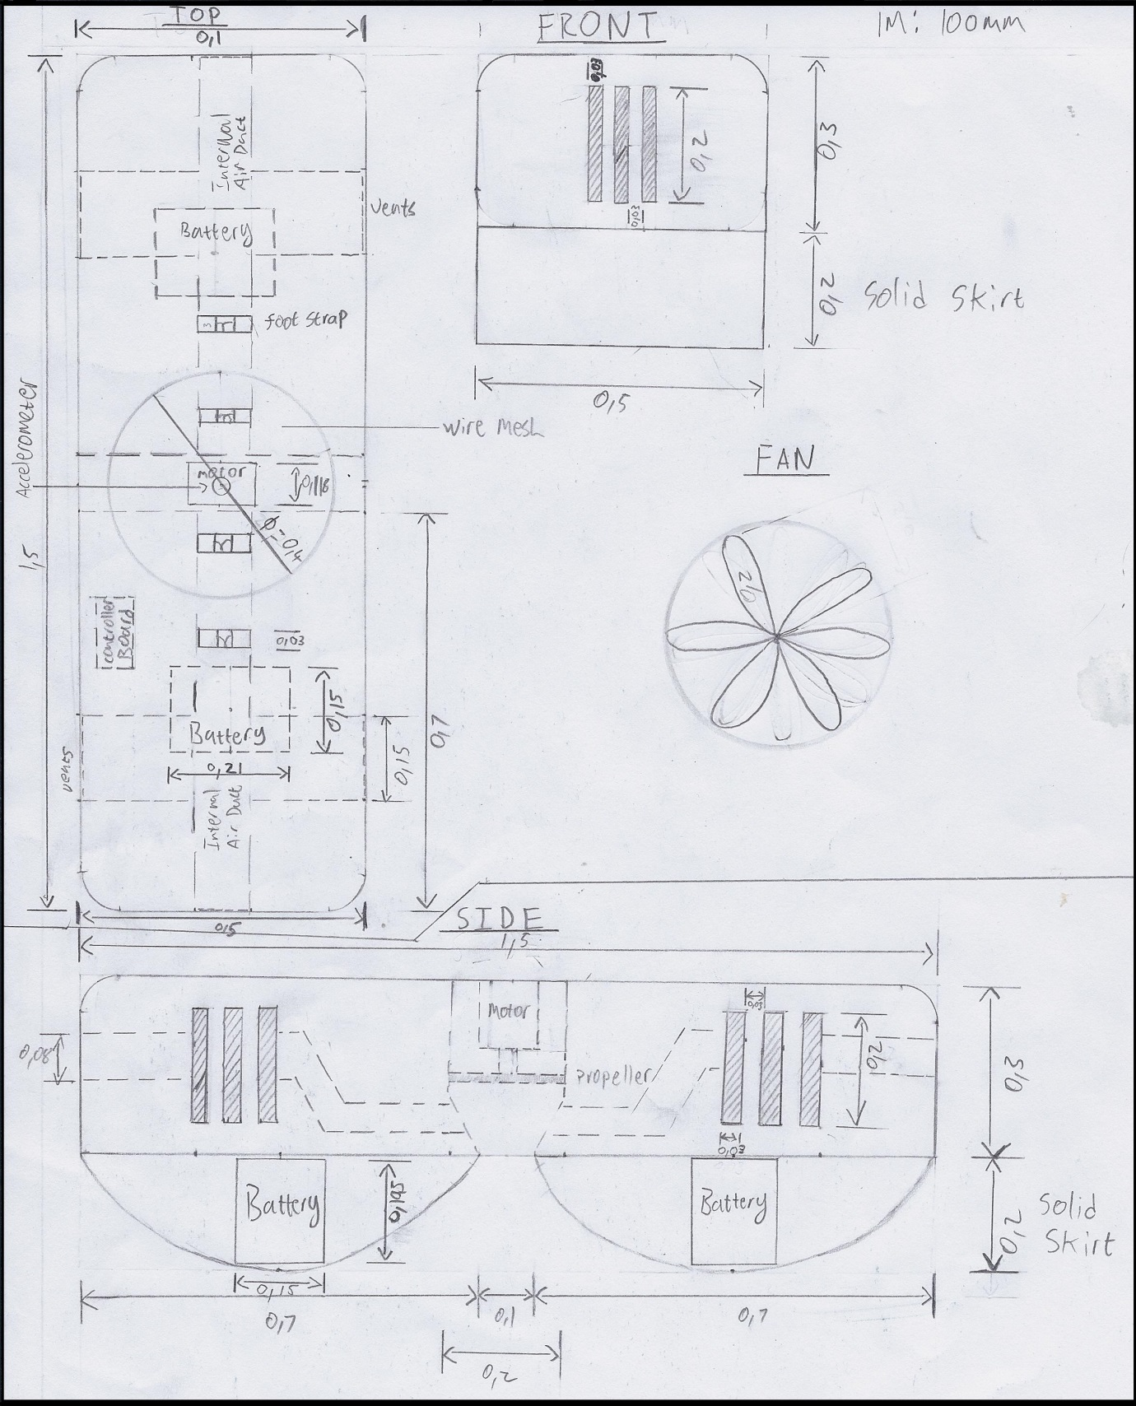

**Appendix A: Electric Diagram**

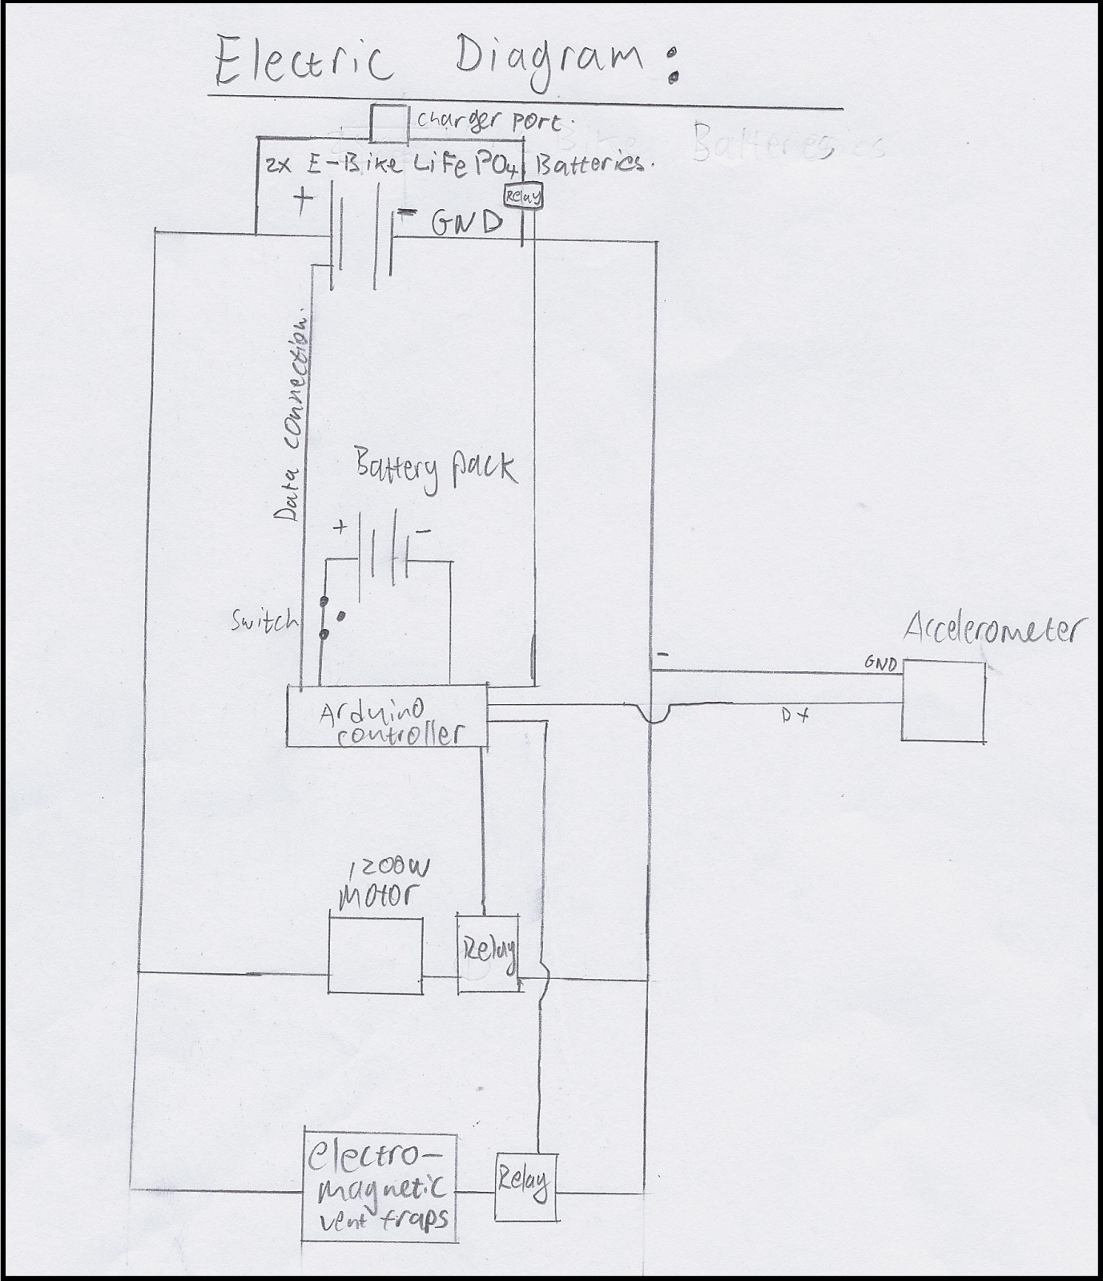

**Appendix B: Mathematical Calculations**

1. **Battery Power Calculations**

48V 20AH

20AH → 72000A (60x60)

1. **Safety Calculations**

Work out the amount of kinetic energy for an 80kg person travelling at 30km/h

This amount of energy is quite small and the absorption of it into the human body may at most cause some injuries such as a broken arm which a person may sustain just by falling down while walking. This type of injury has been accepted as a way of life.

Therefore the hoverboard is safe even though it may cause some injury it is within the same risk thresholds as what people have experienced with other vehicles and everyday life.

**Physical Dimensions**

Thickness of plastic used is 0.01m.

Therefore the dimensions of the Top of the design are 1.5m x 0.5m, the dimensions of the front are 0.5m x 0.5m and the dimensions of the side are 0.5m x 1.5m.

1. **Weight**

**Weight of plastic of the hoverboard:**

**Weight of other components:**

1. **Thrust Considerations**

**Equations:**

**Static Thrust:**

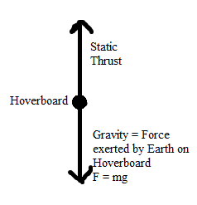Static Thrust = Gravity = 1274N

Gravity = 130 x 9.8 = 1274N

**Specific Physics Tests at Different Accelerations for Vertical Ascension:**

m=130kg vi = 0m.s-1 ∆t=5s g=9.8m.s-2 ST = 1274N

**Test 1: a = 2m.s-2**

**Test 2: a = 0.5m.s-2**

**Test 3: a = 0.25m.s-2**

**Test 4: a = 0.20m.s-2**

**Test 5: a = 0.15m.s-2**

**Results:**

|  |  |  |  |  |  |
| --- | --- | --- | --- | --- | --- |
| Hoverboard test: | Mass (kg) | Acceleration (m.s-2) | Thrust (N) | Height (m) in 5 sec acceleration | Power(W) in 5 seconds |
| 0 STATIC THRUST | 130 | 0 | 1274 | 0 | 0 |
| 1 | 130 | 2 | 1534 | 2 | 15340 |
| 2 | 130 | 0.5 | 1339 | 0.5 | 3185 |
| 3 | 130 | 0.25 | 1306.5 | 0.25 | 1633.125 |
| 4 | 130 | 0.20 | 1300 | 0.20 | 1300 |
| 5 | 130 | 0.15 | 1293.5 | 0.15 | 970.125 |
| **Table to show Hoverboard values when in vertical hover after 5 seconds** | | | | | |

**Physics Calculation to Work out Horizontal Thrust Consideration:**

Let the direction of acceleration on the horizontal plane be positive.

Test 5 has been chosen as the most viable for the specific design.

The motors maximum output is 1200W

The amount of power left in the system for horizontal acceleration is:

Assume ∆t = 40s

1. **Estimated Cost**

Exchange Rate from Dollars to Rands used is: 9.23077

forex-rates.biz/USD/ZAR, Accessed: 28-March-2012

$ 1316 → R12147.69 (2x$658.00) for main Batteries (See [9])

$ 100 → R923.08 Motor for dirt bike (See [10])

R 570 Arduino DUE (See [8])

R 230 Arduino Bluetooth Shield (See [8])

R 215 Arduino Relay Shield (See [8])

$ 145.8 → R1345.84 (6x $24.30) Electromagnets (See [11])

Unfortunately the cost of nylon for SLS is determined by the supply deal with the distributer and so cannot be found at this time.

Estimated Cost Total without Nylon Cost = R15 431.61